CHAPTER: 4
FRONT END OF SYSTEM

4.1 About Front End
4.1.1 about HTML/JSP
4.1.2 About HTML/JSP
4.1.3 about JavaScript
4.2 Major Front End Pages

4.1 About Front End
- The user interface of CodeVerse is built using JSP pages with JSTL tags, HTML, CSS, and JavaScript.
- Role-based views are separated for admin, organizer, participant, and judge.

4.1.1 About HTML/JSP
- JSP view resolution with prefix /WEB-INF/views/ and suffix .jsp
- Reusable page sections and server-side rendered forms
- Dynamic content rendering through JSTL and model attributes

- HTML Page Structure
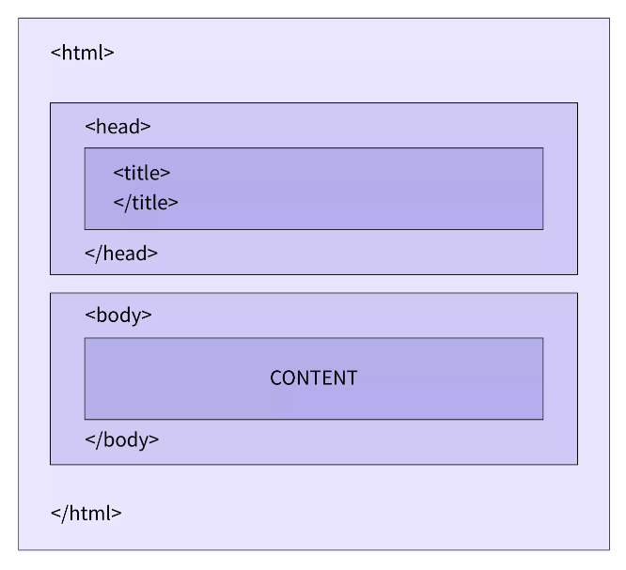
- Any HTML document mainly comprises two parts, the head and the body.
- The Head includes the additional information of the document, apart from the one displayed on the web page.
- It includes the HTML version, the title, and also the metadata.
- And the information that will be displayed on the web page is put inside the Body tag.
- HTML, or Hypertext Markup Language, is the standard language used to create and design web pages.
- It provides the structure and content of a webpage by using a system of markup tags and attributes.

4.1.2 About HTML/JSP
- Custom styles for dashboard pages and forms
- Responsive layout practices for desktop and laptop usage
- Status badges and visual hierarchy for tables/lists

4.1.3 About JavaScript
- Form-level validation and interaction helpers
- - Dynamic field behavior (for example, event type and location rules)
- - Client-side usability enhancements

4.2 Major Frontend Pages
- Login, Signup, Forget Password, Reset Password
- AdminDashboard, ListUser, ListCategory, ListHackathon
- Participant Home, Hackathon Details, MyApplications, MyTeams
- Organizer Applications, JudgeAssignments, Results
- Judge Dashboard and Scorecards

